PANDEMIC PREPAREDNESS PLAN
OF
PATHIYOOR - LSGI

MESSAGE FROM PRESIDENT
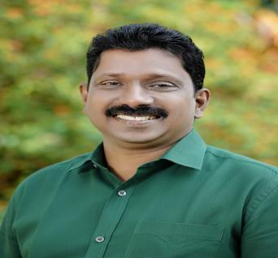
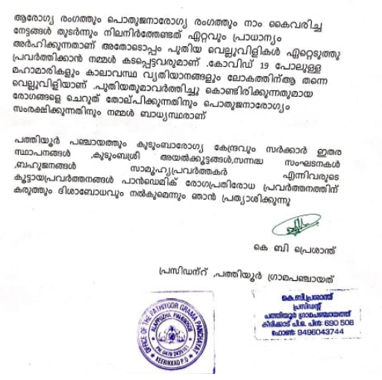

MESSAGE FROM HEALTH STANDING COMMITTEE CHAIR

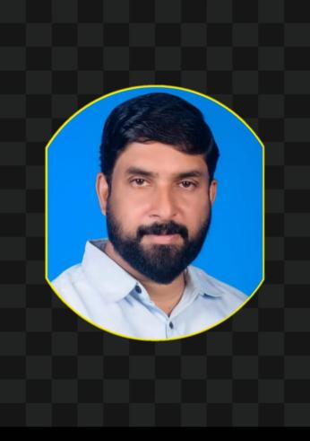

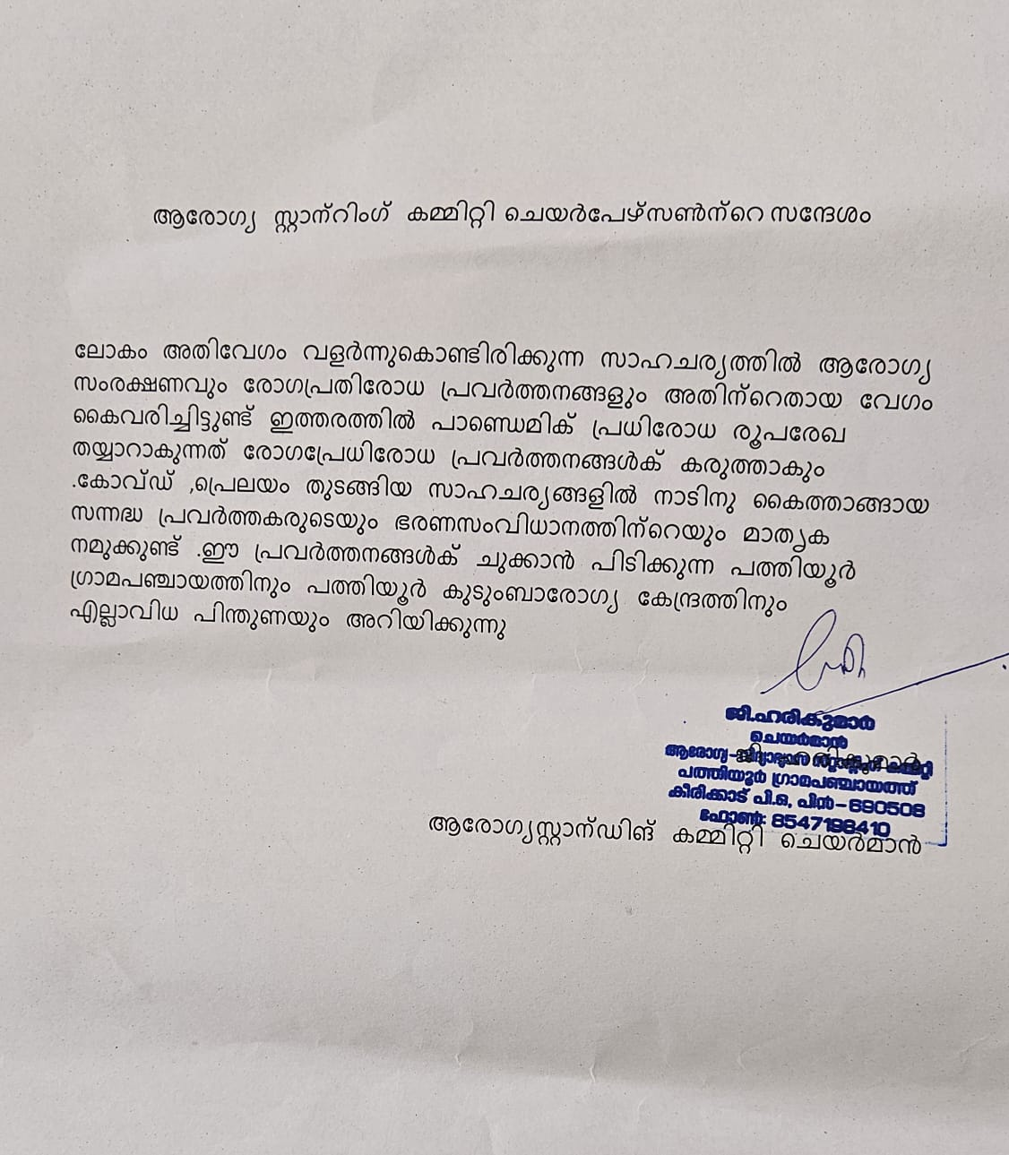

MESSAGE BY MEDICAL OFFICER

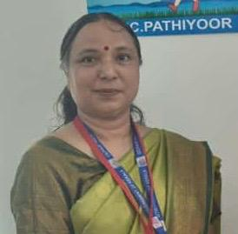

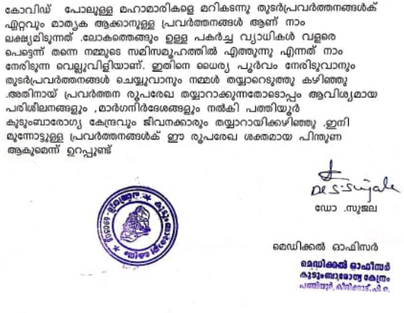
EXECUTIVE SUMMARY

Primary Health Centre (PHC) functions as the primary public healthcare institution serving the population of Pathiyoor. Grama Panchayath. The PHC plays a pivotal role in delivering comprehensive, accessible, and affordable healthcare services, with a strong focus on preventive, promotive, curative, and rehabilitative care in accordance with national and state health programmes.
The FHC caters to a predominantly rural population, addressing key public health priorities such as maternal and child health, communicable and non-communicable disease control, immunization, family welfare, adolescent health, and geriatric care. Regular outpatient services, home-based care through field health staff, and outreach activities ensure healthcare coverage even in geographically challenging areas. The institution actively implements national health missions, including the National Health Mission (NHM), National Tuberculosis Elimination Programme, National Programme for Prevention and Control of Cancer, Diabetes, Cardiovascular Diseases and Stroke (NPCDCS), and other disease surveillance initiatives.
_Pathiyoor FHC works in close coordination with the Grama Panchayath, ASHA workers, Anganwadi centres, schools, and community-based organizations to strengthen community participation and improve health awareness. Emphasis is placed on early detection, timely referral, health education, and lifestyle modification to reduce disease burden and improve overall health outcomes.
Despite constraints related to infrastructure, manpower, and increasing service demand, the FHC continues to enhance service delivery through effective planning, data-driven decision-making, and community engagement. Strengthening facilities, upgrading digital health systems, and expanding preventive services remain key focus areas for future development.
Overall, Pathiyoor Family Health Centre stands as a vital institution in safeguarding public health and improving the quality of life of the residents of _Pathiyoor Grama Panchayath

LIST OF ABBREVIATIONS

LSGD/LSGI | Local Self Government Department / Local Self Government Institution
BMO | Block Medical Officer
IDSP | Integrated Disease Surveillance Programme
NDMA | National Disaster Management Authority
PPE | Personal Protective Equipment
ICMR | Indian Council of Medical Research
CD | Communicable Diseases
NCD | NON-COMMUNICABLE Diseases

TABLE OF CONTENTS

3
INTRODUCTION 09
LSGD AT A GLANCE 10
INTEGRATED HEALTH INFRASTRUCTURE MAP OF KRISHNAPURAM PANCHAYAT 12
GENERAL PROFILE OF THE LSGI’S 16
Background of the LSGI 16
Demographic and Vulnerable Population 17
Clinical Vulnerability 18
INFRASTRUCTURE & RESOURCE INVENTORY 20
Health Facility Directory & Basic Capacity in the LSGD 21
Private Clinics 22
Healthcare Education & Training Institutions 22
Specialized Services & Emergency Inventory 23
Oxygen & Diagnostic Capacity 24
Diagnostics facility mapping at the LSGI level 24
Laboratory Identification & Basic Details 25
Social and Community Infrastructure for surge plan 26
Human resources 28
Community & Support Cadre 30
Community Organizations 31
Administrative & Emergency Services 32
Information regarding resources 32
ONE HEALTH & ENVIRONMENTAL SURVEILLANCE 33
Animal & Bird Population 34
Veterinary Infrastructure 35
Veterinary Doctors & Workforce 36
High-Risk Interface Points (Surveillance Sites) 36
Environmental Risk Mapping 38
Disease Seasonality Mapping 39
Vulnerability Mapping 41
EPIDEMIOLOGICAL TRENDS (2021–2025) 42
Disease Burden among human beings(Last 5 Years) 42
*(use the above table data to create the graph/diagram) 43
Seasonal Trend Analysis 44
Outcome-Based Trend Analysis- 2025 49
Transmission Trend- 2025 50
Integrated Disease Hotspot Map (2021–2025) 53
Preparedness and Response Protocol at LSG Level 57
Constitution of One Health Committee 58
Pandemic Response Workforce 59
Activities and Measures before and during Pandemic 59
PHASE 1 - Alert / Preparation 60
PHASE 2 - Active Response 63
Standard Screening Protocol 64
PHASE 3 - Surge Capacity 60
Conversion of Community Facilities 74
CONCLUSION 76
RECOMMENDATIONS 76
ANNEXURE 77
1. IMPORTANT PHONE NUMBERS 77

INTRODUCTION

Pathiyoor Grama Panchayat, located in Alappuzha district of Kerala, is a semi-rural area characterized by a mix of low-lying lands, agricultural fields, and residential settlements. The geographical features of the Panchayat, including its proximity to water bodies and its susceptibility to seasonal climatic variations, play an important role in shaping the living conditions and health profile of the population. During the monsoon season, the area may experience waterlogging and related environmental challenges, which can impact sanitation and public health.
The Panchayat is home to a diverse population engaged in occupations such as agriculture, small-scale industries, trade, and service sector jobs. Over time, there has been a shift in socio-economic patterns with increased migration and changing livelihood practices. The presence of vulnerable groups, including elderly individuals, children, and people with chronic illnesses, highlights the importance of ensuring accessible and equitable public services, particularly in healthcare and social welfare.
Pathiyoor has an active Local Self Government system that plays a crucial role in implementing developmental programmes, public health initiatives, and welfare schemes. The Panchayat works in close coordination with health institutions, ASHA workers, Anganwadi centres, and other community stakeholders to ensure effective service delivery and community engagement. In the face of evolving environmental and health challenges, Pathiyoor continues to focus on strengthening infrastructure, improving preparedness, and promoting community participation for sustainable and resilient development.

LSGD AT A GLANCE

ADMINISTRATIVE BOUNDARIES OF PATHIYOOR PANCHAYATH

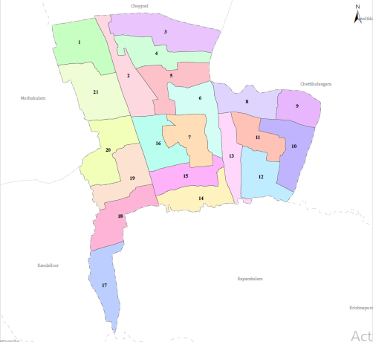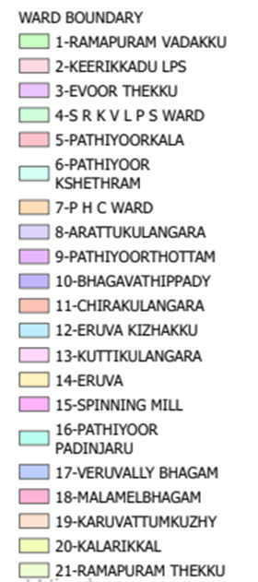

- Ward division -
Ward | Houses | Population | Migrants | Wells | Hot  spots | Ed. Institutions | Hosp pvt/govt.
1 | 503 | 1740 | 20 | 462 | 0 | 3 | 0
2 | 517 | 2298 | 14 | 467 | 0 | 2 | 0
3 | 481 | 2003 | 18 | 476 | 0 | 1 | 0
4 | 496 | 2007 | 13 | 490 | 0 | 0 | 0
5 | 502 | 1860 | 8 | 496 | 0 | 0 | 1
6 | 447 | 1725 | 14 | 415 | 0 | 0 | 0
7 | 512 | 2022 | 28 | 489 | 0 | 1 | 0
8 | 521 | 1934 | 19 | 487 | 0 | 1 | 0
9 | 532 | 2356 | 21 | 456 | 0 | 0 | 0
10 | 514 | 2178 | 5 | 478 | 0 | 2 | 0
11 | 565 | 2250 | 32 | 512 | 0 | 0 | 0
12 | 558 | 2312 | 13 | 503 | 0 | 0 | 0
13 | 507 | 2123 | 9 | 500 | 0 | 1 | 0
14 | 521 | 1985 | 8 | 492 | 0 | 0 | 0
15 | 512 | 2014 | 18 | 493 | 0 | 2 | 0
16 | 492 | 2034 | 28 | 460 | 0 | 1 | 1
17 | 519 | 2112 | 20 | 487 | 0 | 0 | 1
18 | 503 | 2037 | 17 | 493 | 0 | 0 | 0
19 | 530 | 2114 | 16 | 489 | 0 | 0 | 0

INTEGRATED HEALTH INFRASTRUCTURE MAP OF PATHIYOOR PANCHAYAT
GOVERNMENT ,PRIVATE HOSPITALS AND CLINICS

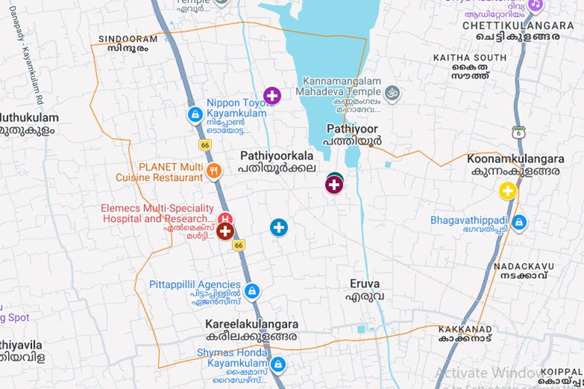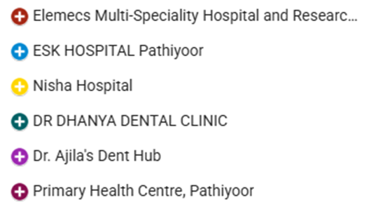
https://www.google.com/maps/d/edit?mid=1_qf5UeMe-YSYajOX7AB8b7LLB9Pt-YI&ll=9.215987395109313%2C76.4670774863518&z=14

MAJOR ROADS

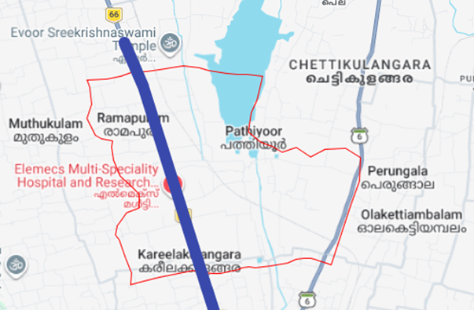

https://www.google.com/maps/d/edit?mid=1rvKSzontCaSHdXIGE2xpCYyqOoGwqV8&ll=9.20072645095594%2C76.43212891874384&z=13

Schools in grama Panchayath
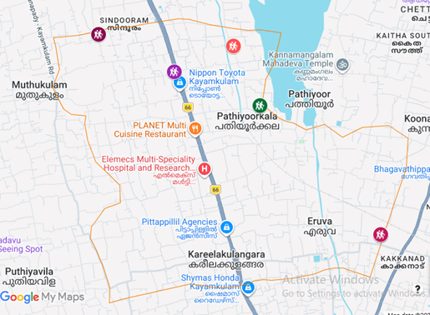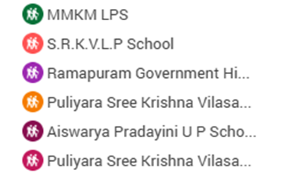

https://www.google.com/maps/d/edit?mid=1driv6S7pu0BTMVrLOJcW9iDc1-2Mkjk&ll=9.21071439128401%2C76.45953566145397&z=14

GOVERNMENT OFFICES

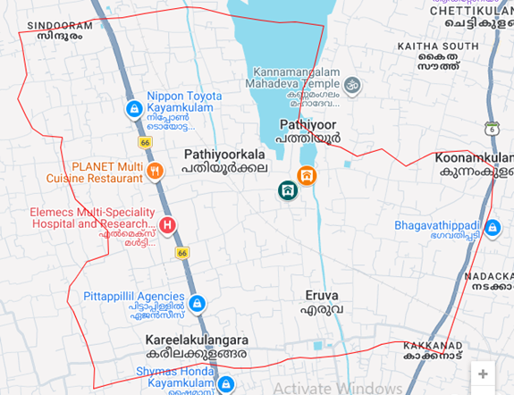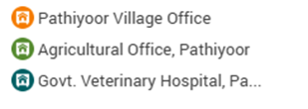

https://www.google.com/maps/d/edit?mid=1dxHyHg4REcvhRqREBMSjB1QHEZkI1nY&ll=9.209194610334741%2C76.45970057143764&z=14

SCHOOLS LOCATIONS IN THE GRAMA PANCHAYATH

https://www.google.com/maps/d/edit?mid=1driv6S7pu0BTMVrLOJcW9iDc1-2Mkjk&ll=9.207011266384272%2C76.48580804999997&z=14

COMMUNITY HALLS

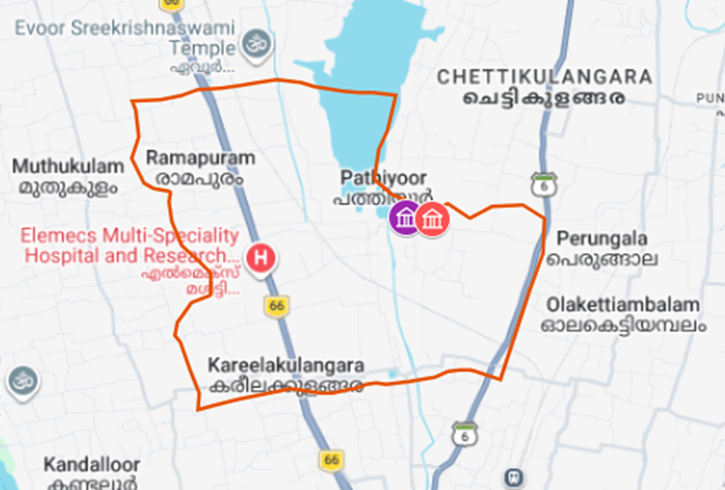

https://www.google.com/maps/d/edit?mid=1yJCyB2g8Iumi_IBmgnTnXLe8USnJfDk&ll=9.217120549109666%2C76.47019222639493&z=13

–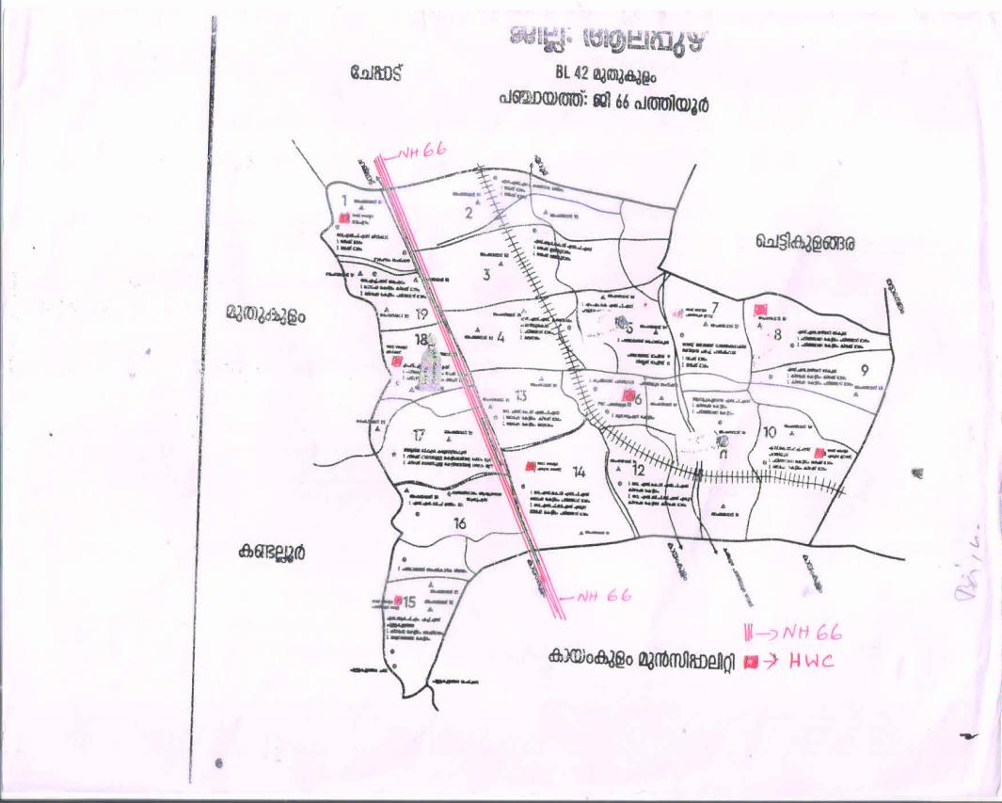

GENERAL PROFILE OF THE LSGI’S

Background of the LSGI
Pathiyoor Grama Panchayat, situated in Alappuzha district of Kerala, is a semi-rural Local Self Government area characterized by a combination of agricultural land, residential settlements, and interconnected water bodies. The geographical setting, including low-lying areas and seasonal climatic variations, influences both the livelihood patterns and environmental conditions of the Panchayat. During monsoon seasons, the area is prone to waterlogging and sanitation challenges, which can increase the risk of communicable diseases and affect service delivery systems.
The Panchayat has a moderately dense population engaged in agriculture, small-scale industries, and service sector occupations, with changing socio-economic trends due to migration and urban influence. The presence of vulnerable groups such as the elderly, children, and individuals with chronic illnesses requires focused attention in planning and implementation of welfare and health programmes. From a public health perspective, Pathiyoor faces risks related to vector-borne and water-borne diseases, especially during seasonal changes. These factors highlight the importance of strong local governance, effective intersectoral coordination, and community participation to ensure resilience and efficient management of public health and developmental challenges.

Table 1: Background of LSGD
Description | Details
Name of LSGI | PATHIYOOR
Type (GP/Municipality / Corporation etc.) | Grama Panchayath
Block | MUTHUKULAM
District | ALAPPUZHA
Number of wards | 21
Total area (sq. km) | 16.27 sq.km
Population(Projected) | 39744
Population density | 993.6persons/sq km
Terrain (coastal/low-lying/backwaters/foothills, etc.) | NIL
Number of rivers passing through LSGI | 0
Number of water bodies in the LSGI | 39
Number of educational institutions | 18
Factories / small-scale industries | 3
Flood-prone wards | 6,7,12
Landslide-prone wards | nil
Death Management and Disposal Facilities (mortuaries/crematorium, including electric) | NIL
Auditoriums/Marriage halls/convention centres/community halls | 4

Demographic and Vulnerable Population
Understanding the demographic composition and vulnerable population groups is essential for pandemic preparedness. Children, elderly, economically deprived families, migrant workers, and socially vulnerable groups are at increased risk during public health emergencies due to higher exposure, limited access to services, and dependency on public systems..

Description |  | Details (in numbers)
DEMOGRAPHIC PROFILE
Total population |  | 39744
Male |  | 19360
Female |  | 20384
Transgender |  | 0
Children under 5 |  | 1375
Adolescent |  | 2677
Elderly (>60) |  | 7573
SOCIAL/LIVELIHOOD VULNERABILITY
Previous EPEP family |  | 66
BPL family |  | 4123
Tribal communities |  | 1
Migration | Immigrant | 456
 | Emigrant | 876
Socio-economically deprived |  | 98
Fisherfolk |  | 23
SC Community |  | 3243
ST Community |  | 132

Graphs: Population pyramid (if possible) for seeing if your LSGI has a high "dependency ratio" (lots of children and elderly compared to working adults).

Clinical Vulnerability
Certain population groups needs priority healthcare & are at higher risk of severe illness, complications, and mortality during pandemics. Patients with chronic diseases, those requiring regular medical care, and individuals with mobility or functional limitations face challenges in accessing timely care during emergencies. Mapping these groups helps in prioritizing continuity of treatment, medicine stock planning, oxygen support, referral transport, and targeted home-based care.
Description | Details in numbers
Pregnant women | 169
Lactating mothers | 148
Bedbound patients | 84
Patients under palliative care other than bedbound | 190
Patients on Haemodialysis | 17
Patients on CAPD | 0
Cancer patients (currently on treatment) | 194
Haemophilic patients | 0
Mentally challenged | 107
Differently abled | 123
Diabetic patients | 3031
Hypertensive patients | 4223
TB patients | 5

Major Festivals & Events specific to the LSGI
(with the possibility of a public gathering)

Sl. No. | Name of festival | Month detailing the periodicity
1 | PATHIYOOR TEMPLE FESTIVAL | MARCH,APRIL
2 | RAMAPIRAM TEMPLE | MARCH,APRIL

INFRASTRUCTURE & RESOURCE INVENTORY

Health Facility Directory & Basic Capacity in the LSGD
This section provides an overview of the healthcare infrastructure available within the LSGD area. It outlines the distribution and basic capacity of health facilities that form the backbone of service delivery during routine times and public health emergencies.

Family Health Centres (FHCs) and Community Health Centres (CHCs) generally function as the first point of contact for the community, providing essential outpatient and inpatient services. General Hospitals (GH) and Medical College Hospitals (MCH), where accessible, serve as the main referral centres for advanced diagnostics, specialist care, and critical services during public health emergencies. This inventory helps identify existing strengths, gaps, and potential surge capacity that can be mobilised during a pandemic or disaster.

Table 5. Health Facility Resource Summary
Sl.no. | Health Facility | Type of Facility (MCH/GH/CHC/FHC/SC etc.) | Contact Number | Total beds | ICU Beds | Oxygen-Supported Beds | No. of Ventilator Support Beds | No. of ambulances
Government Healthcare Facilities
1 | FHC PATHIYOOR | FHC | 9447727430 | 0 | 0 | 0 | 0 | 0
2 | MAIN CENTER | SC | 8893638948 | 0 | 0 | 0 | 0 | 0
3 | PATHIYOOR EAST | SC | 8111800751 | 0 | 0 | 0 | 0 | 0
4 | ERUVA EAST | SC | 9745282486 | 0 | 0 | 0 | 0 | 0
5 | PATHIYOOR WEST | SC | 8113091141 | 0 | 0 | 0 | 0 | 0
6 | KEERIKKAD | SC | 94463693 | 0 | 0 | 0 | 0 | 0
7 | RAMAPURAM | SC | 9383452378 | 0 | 0 | 0 | 0 | 0
8 | ERUVA WEST | SC | 9745832682 | 0 | 0 | 0 | 0 | 0
Private Healthcare Facilities
1 | ELEMECS HOSPITAL | HOSPITAL | 9809191616 | 27 | 27 | 27 | 3 | 2
AYUSH Healthcare Facilities
1 | AYUSH PATHIYOOR | HOSPITAL | 9447860200 | 0 | 0 | 0 | 0 | 0

Private Clinics
Private clinics are an essential part of pandemic preparedness, as they are often the first place people seek care when symptoms begin. In many communities, private clinics manage a significant share of outpatient visits and therefore play a critical role in early case detection, timely referrals, and disease surveillance. Having an up-to-date understanding of where these clinics are located, the services they provide, and how they are linked to the public health system helps ensure that no cases are missed during an outbreak. It also allows health authorities to engage private practitioners more effectively for reporting, risk communication, and coordinated response, strengthening the overall capacity of the health system to manage public health emergencies.

Table 6. Private Clinic Resource Summary
Sl No. | Name of Clinic | Registered (Y/N) | Clinic (General / Speciality) | Speciality (if any) | Address | Contact Number | Diagnostic Facility (Y/N) | Ambulance Linkage (Y/N)
1 | ESK HOSPITAL | NO | NO | NO | ESK HOSPITAL,PATHIYOOR | 9567523322 | N | N
2 | NISHA HOSPITAL | NO | NO | NO | NISHA BHAVANAM  BHAGAVATHIPPADI | 9556215481 | N | N
3 | PRETHYASA HOSPITAL | NO | NO | NO | ATHIKKATTTHARAYIL ERUVA WEST | 9048300818 | N | N
4 | DERMA DENTAL TRUST | NO | NO | NO | DERMA DENTAL TRUST | 7025633525 | N | N
5 | DR AJILAS DENTAL HUB | NO | NO | NO | AMBAZHAVELIL BUILDING ,KEERIKKAD | 9645480987 | NO | NO
6 | DHANYA DENTAL CLINIC | YES | NO | NO | KEERIKKAD,PATHIYOOR | 7559049931 | NO | NO

Healthcare Education & Training Institutions
This section tracks the educational infrastructure available, which is vital for human resource planning in the health sector.

Category of Institution | Govt | Private | AYUSH | Total
Medical Colleges | 0 | 0 | 0 | 0
Nursing Colleges | 0 | 0 | 0 | 0
Dental Colleges | 0 | 0 | 0 | 0
Para-medical / Allied Health | 0 | 0 | 0 | 0
Pharmacy Colleges | 0 | 0 | 0 | 0

Specialized Services & Emergency Inventory
This section provides a detailed view of the specialized medical resources available to the community, focusing on emergency response and critical care capabilities. This table tracks the vital assets required for managing severe illnesses and emergencies across Government, Private, and AYUSH sectors.

Item | Govt | Private | AYUSH | Total
Hospital beds | 0 | 27 | 0 | 27
Oxygen-generating systems(Y/N) | 0 | 27 | 0 | 27
Oxygen-supported beds(Numbers) | 0 | 8 | 0 | 8
Ventilator-supported beds | 0 | 6 | 0 | 6
ICU beds | 0 | 6 | 0 | 6
Burns units | 0 | 5 | 0 | 5
Blood centres | 0 | 0 | 0 | 0
BLS ambulances | 0 | 1 | 0 | 1
ALS ambulances | 0 | 1 | 0 | 1
Dialysis facilities | 0 | 1 | 0 | 1
Dispensaries | 0 | 4 | 0 | 4
Medical store | 1 | 1 | 0 | 2
Industrial establishments(Medium-scale industries/small-scale industries establishments to whom we can depend in a worst-case scenario) | 1 | 0 | 0 | 1

Oxygen & Diagnostic Capacity
Monitoring oxygen and diagnostic capacity is a critical component of public health preparedness, ensuring that the LSGD can handle both chronic care and sudden surges in respiratory or infectious diseases.
Name of Health Facility | Oxygen-generating System (Y/N) | Backup Oxygen Source (Y/N) | Diagnostic Facilities Available(Y/N)
 |  |  | Lab | USG | X-ray | CT/MRI | RT-PCR
Government Healthcare Facilities
nil | nil | ni.l | yes | no | no | no | no

Diagnostics facility mapping at the LSGI level
The diagnostic capacity of pathiyoor G.P represents the "intelligence network" of our healthcare system. The speed and accuracy of disease identification depend entirely on the distribution and technical level of these facilities.

Item | Govt | Private | AYUSH | Total
General labs | 1 | 1 | 0 | 1
Microbiology labs | 0 | 1 | 0 | 1
RT-PCR labs | 0 | 0 | 0 | 0
USG units | 0 | 1 | 0 | 1
CT/MRI units | 0 | 1 | 0 | 1
Research labs | 0 | 0 | 0 | 0
Labs of other departments that can be repurposed | 0 | 0 | 0 | 0

Laboratory Identification & Basic Details
Sl. No. | Name of Laboratory | Ownership (Govt / Private / Academic) | Address | Contact No. | 24×7 Services (Yes/No) | NABL / Govt Approved (Yes/No)
1 | PHC PATHIYOOR | GOVT | FHC PATHIYOOR |  | NO | NO
2 | MODERN LABORATORY | PRIVATE | PATHIYOOR | 8589838425 | NO | NO
3 | DR LAL PAP LAB | PRIVATE | PERINGALE | 9847743508 | NO | NO
4 | WELL CARE | PRVT | KAREELAKULANARA | 9562858005 | NO | NO
5 | SURYA LAB | PRVT | KAREELAKULANGARA | 8526794429 | NO | NO
6 | NEELIMA LAB | PRVT | PATHIYOOR | 9846265716 | NO | NO
7 | MCDC PATHIYOORKALA | PRVT |  | 9539457900 | NO | NO
8 | ODANAD ECG &DIAGNOSTICS | PRVT | KAREELAKULANGARA | 9495163262 | NO | NO

Social and Community Infrastructure for surge plan
This table serves as our logistics and shelter inventory. By mapping these locations, quickly we can identify where to house displaced citizens, where to set up temporary medical clinics, and how to manage the deceased with dignity during a crisis.

Category | Total Count | Ward | Est. Capacity (Persons) | Contact details
Educational Institutions
Anganwadis | 32 | NIL | NIL
Schools | 16 | 1,10,6 | 100
Colleges | 2 | 6,17 | 250
Healthcare Educational Institutions
Medical colleges (Govt/Private) | NIL
Nursing colleges (Govt/Private) | NIL
Dental colleges (Govt/Private) | NIL
Paramedical institutes (Govt/Private) | NIL
Community Gathering Spaces
Community halls | 4 | 150
Auditoriums | 2 | 600
Religious buildings | 1 | 50
Vulnerable Group Support Facility
Destitute homes | 0 | 0
Elderly homes | 1 | 13
LSGD owned other buildings | 0 | 0
Mass Fatality Management (MFM) Infrastructure
Mortuary | 0
Crematorium | 1
*refer annexure 1 for contact details

Human resources
This section focuses on the human capital available within the LSGI. In any emergency—be it a pandemic, flood, or industrial accident—infrastructure is only as effective as the people operating it.

Medical & Clinical Personnel
This table tracks the "Frontline" providers responsible for diagnosis, treatment, and clinical management. Narrative sentence: eg., "Total health workforce: 450 personnel, with 60% in government facilities serving as primary surge capacity." A detailed directory with the contact numbers of all workers is maintained (Annexure in 1).

Cadre | Govt (No.) | Private (No.) | Total
Doctors—Modern Medicine | 3 | 32 | 35
Doctors – AYUSH | 2 | 5 | 7
Doctors – Veterinary | 1 | 0 | 1
Doctors – Dental | 0 | 6 | 6
Nursing officers | 2 | 46 | 47
Lab technicians | 1 | 16 | 17
Optometrist | 0 | 0 | 0
Pharmacists | 2 | 15 | 17
Psychologists | 0 | 0 | 0
Counsellors | 0 | 1 | 1

Public Health & Field-Level Workforce
These individuals are the backbone of surveillance, maternal-child health, and decentralized care.

Cadre | Health services | Municipal common services | Total
HS (Health Supervisors) | 0 | 0 | 0
HI (Health Inspectors) | 1 | 0 | 1
LHS (Lady Health Supervisor) | 0 | 0 | 1
LHI (Lady Health Inspectors) | 1 | 0 | 1
JPHN (Jr Public Health Nurses) | 7 | 0 | 7
JHI (Jr Health Inspectors) | 4 | 0 | 4
MLSP (Mid-Level Service Providers) | 7 | 0 | 7
Palliative Nurses | 1 | 0 | 1
RBSK Nurses | 1 | 0 | 1
PRO | 0 | 0 | 0
Epidemiologist | 0 | 0 | 0
Data Manager | 0 | 0 | 0

Community & Support Cadre
This group represents the surge capacity of the LSGI—people who can be called upon for logistics, rescue, and specialized support.

Cadre | Number
ASHA Workers | 27
AWW (Anganwadi Workers) | 64
Emergency Medical Volunteers (Trained) | 0
Kudumbashree | 360
MNREGS | 1798
Purusha Swayam Sahaya Sangham | 0
Ex-Servicemen | 344
Retired Police Officers | 92
NCC/NSS Volunteers | 100
Red Cross volunteers | NIL
One Health Community Volunteers | 931
One Health Community Mentors | 133

Community Organizations
This section details the presence of community-based organisations (CBOs), non-governmental organisations (NGOs), faith-based organisations (FBOs), Kudumbashree Self-Help Groups (SHGs), and Ayalkootams within the Local Self-Government Institution (LSGI). These groups enhance grassroots mobilization, resource distribution, and support networks crucial for pandemic response and community resilience.

Category | Total Count
NGOs | 2
Religious based organizations | 1
Foreign based organizations | 0
Sports Club/youth clubs | 3
Kudumbashree SHGs | 320
Ayalkootams | 324
Political organizations
Residential organizations

Administrative & Emergency Services
This section outlines the availability of key non-health emergency support services and infrastructure within the LSGI, which are essential for effective pandemic preparedness and response. These facilities support law enforcement, disaster response, water supply, logistics, mobility, and community-level interventions during public health emergencies.

Category | Total Count | Contact details
Police Stations | 0 | 0
Fire & Rescue Stations | 0 | 0
Water Pumping Points | 0 | 0
Public Distribution System (PDS) | 0 | 0

Information regarding resources
The availability of essential transport and support resources plays a quiet but critical role in saving lives. Equipment such as ambulances, mobile mortuaries, amphibian ambulances, and motorized boats ensures that patients, samples, and healthcare teams can move swiftly—even in flooded, remote, or difficult terrains. Heavy vehicles like JCBs, cranes, tractors, and torus lorries support logistics, waste management, emergency infrastructure, and rapid conversion of spaces into care or isolation facilities. Taxis, four-wheel-drive vehicles, and trucks help maintain continuity of essential services, reach vulnerable populations, and support home-based care and supply delivery.

Means of transportation | Total Count
JCB | 2
Crane | 0
Heavy Trucks | 0
Tractor | 0
Ambulances | 0
Mobile mortuaries | 0
Boats | 0
Taxi service | 6
Note: For specific details regarding vehicle owners and contact information, please refer to Annexure [X].

ONE HEALTH & ENVIRONMENTAL SURVEILLANCE
The One Health method integrates environmental, animal, and human health to enable proactive pandemic preparedness. Panchayat-level surveillance needs to be improved in order to detect and treat zoonotic and environmentally generated diseases early. Surveillance is strengthened through systematic assessment of animal populations, veterinary infrastructure, poultry and slaughter facilities, inter-sectoral coordination, and specialised tools like avian influenza seasonality mapping using GIS in previous outbreaks to enable predictive alerts and ward-specific sampling to support effective pandemic preparedness in high-risk areas like.

Animal & Bird Population
Mapping animal and bird populations at the Panchayat level is essential for identifying and prioritising zoonotic disease hazards like rabies, avian influenza (H5N1), leptospirosis, anthrax, and Nipah-like spillover occurrences. Risk classification, targeted surveillance, vaccination planning, and early epidemic detection made feasible by comprehensive population mapping all enhance One Health-based pandemic preparedness.

Category | Item | Estimated Population
Animal Population | Livestock (Cattle/Goats/Buffalo) | 976
 | Pet Animals (Dogs/Cats) | 321
 | Stray Dog Population | 2134
 | Pig Farms (Number of heads) | NIL
 | Small Units (Sheep / Goats – clustered) | NIL
Bird Population | Poultry Units (Birds) | 5670
 | Poultry- (FOWL) | 3456
 | Wild/Migratory Birds (Observed) | 0
 | Crow Mortality Events (Reported) | 0

The main risk of zoonotic diseases in concentrated in Wards which is explained by the high density of pig farms, cattle congregation areas, and poultry units. The stray dog population in market areas, fish landing sites, bus stations continues to be a substantial problem for rabies surveillance and bite prevention. There is a considerable risk of avian influenza introduction and amplification during November - December due to the seasonal presence of migratory and resident water birds near ponds/ canal / river / backwater / paddy field. Clusters of pig farms and animal shelters vulnerable to flooding further raise the risk of leptospirosis and other zoonoses mediated by the environment, especially during monsoon floods.

Veterinary Infrastructure
Veterinary institutions are a core pillar of One Health surveillance, enabling early zoonotic disease detection through vaccination, investigation of unusual animal illness or deaths, sample collection, and timely outbreak reporting. A well-mapped and responsive veterinary network strengthens coordination with human health and LSGI systems, ensuring rapid response during zoonotic events and pandemics.
Facility Type | Name of Facility | Ownership Govt / Pvt | Location(Ward No) | Contact number
Veterinary Dispensary | NIL
Veterinary Hospital / Polyclinic | Govt.vetenary hospital | govt | 7 | 9447279981
Private Veterinary Clinics | NIL
Mobile / Emergency Vet Service (incl. night services) | NIL
Pet Homes / Animal Shelters | NIL
Slaughterhouse-linked Veterinary Inspection Unit | NIL

Veterinary Doctors & Workforce
Early detection, diagnosis, reporting, and reaction to animal illness epidemics depend on the availability and accessibility of qualified veterinary specialists. By identifying unusual animal morbidity or mortality promptly, collecting samples promptly, and coordinating efficiently with human health and LSGI systems—especially during zoonotic outbreaks and pandemic-prone situations—a clearly defined veterinary workforce enhances One Health surveillance.

Category | Number Available | Type (Govt/Pvt) | Contact number
Government Veterinary Doctors | YES | GOVT | 9447279981
Private Veterinary Doctors | NIL
Livestock Inspectors | YES | GOVT | 8547911863
Para-veterinary Staff / Attenders | NIL
Contract / On-call Veterinary Support (if any) | NIL

High-Risk Interface Points (Surveillance Sites)
High-risk interface points for zoonotic disease surveillance in Pathiyoor Grama Panchayath include wetland–livestock–human contact zones, backyard poultry farms, cattle sheds near water bodies, fish markets, and areas of high human–animal interaction such as community slaughter points and migratory bird congregation sites. These are the primary surveillance sites where zoonotic spillover risks are elevated.

Type of Habitat | Type of High risk interface
Wetlands & Backwaters | NL
Backyard Poultry Farms | NIL
Cattle Sheds near Water Bodies | NIL
Fish & Meat Markets | NIL
Community Slaughter Sites | NIL
Migratory Bird Congregation Areas | NIL
Rodent-Infested Grain Storage | NIL

Category | Total Count
Poultry Farms | NIL
Backyard / Clustered Poultry Units | NIL
Duck Rearing Units (open water access) | NIL
Slaughterhouses/ Slaughter Points | NIL
Meat/Fish Markets | 1
Live Bird Sale Points | NIL
Cattle Markets / Weekly Animal Fairs | NIL
Pet Shops / Breeders | NIL
Animal Shelters / Pet Homes | NIL
Waste Disposal Sites near Animal Units | NIL

Environmental Risk Mapping
Environmental risk mapping identifies monsoon/flood hotspots for vector-borne (dengue, chikungunya), water-borne (leptospirosis, diarrhoea), and zoonotic diseases in Kerala's wetlands. Systematic surveillance supports early warnings, targeted interventions, and Panchayat pandemic preparedness.
Waterborne exposure: Flood-prone areas and stagnant water bodies facilitate leptospira survival, raising leptospirosis risk.

Traditional practices: Informal slaughter and fish markets lack standardized hygiene, creating spillover opportunities.

Risk Factor | High-Risk Wards | Key Locations | Risk Level (High/Med/Low)
Flood-prone areas | 6,7,12 | ,PATHIYOOR EASTT
Water bodies/wetlands | NIL
Solid waste accumulation | NIL
Animal waste disposal issues | NIL
Rodent infestation zones | NIL
Industrial effluent discharge | NIL
Construction sites / abandoned buildings | NIL
Poor drainage/blocked canals | NIL
Drinking water source contamination risk | NIL

Disease Seasonality Mapping
1, Flooding & waterlogging → amplifies leptospirosis, malaria, diarrheal diseases.
·
2, Migratory bird influx (Nov–Feb) → avian influenza risk.

3, Mosquito breeding cycles → vector-borne disease peaks in monsoon.

4, Agricultural practices → close human–animal contact in paddy fields.

Disease | Peak Risk Season | Key Drivers
Avian Influenza | NIL | NIL
Leptospirosis | NIL | NIL
Dengue/Chikungunya | NIL | NIL
Acute Diarrheal Diseases | NIL | NIL
Rabies | NIL | NIL
Anthrax (rare) | NIL | NIL

Vulnerability Mapping
Vulnerability mapping pinpoints high-risk populations, occupations, and areas exposed via environment, livelihoods, socio-economics, and poor service access. Paired with environmental/seasonality mapping, it enables risk-based surveillance, targeted actions, and optimal resource use in One Health and pandemic planning.
Vulnerability Factor | High-Risk Wards
Flood-prone households | 6,7,12,
Wetland-adjacent communities | NIL
Backyard poultry / duck rearing households | NIL
Livestock-rearing households | NIL
Slaughterhouse & meat market workers | NIL
Fisherfolk & fish market workers | NIL
Sanitation workers | NIL
Daily wage / migrant workers | NIL
Elderly & chronically ill populations | NIL
Pregnant Women | NIL
Children (schools, Anganwadi’s) | NIL
Limited access to safe water & sanitation | NIL

EPIDEMIOLOGICAL TRENDS (2021–2025)

Disease surveillance is the systematic collection, analysis, and interpretation of health data for planning, implementation, and evaluation of public health practice. This section presents the disease surveillance profile of the LSGI based on routine reporting systems and outbreak investigations to identify priority diseases, seasonal patterns, and emerging public health threats.

Disease Burden among human beings(Last 5 Years)
Analysis of disease-wise data for the last five years helps identify persistent public health problems, emerging diseases, and changes in disease burden. This information supports prioritisation of prevention, preparedness, and response activities at the Panchayat level.

Disease | 2021 | 2022 | 2023 | 2024 | 2025 | Trend(Increasing/Stable/Decreasing)
Dengue | 3 | 5 | 2 | 73 | 10 | STABLE
Leptospirosis | 1 | 3 | 4 | 1 | 0 | STABLE
Hepatitis A | 0 | 0 | 0 | 3 | 1 | STABLE
Malaria | 0 | 1 | 1 | 1 | 0 | STABLE
Scrub Typhus | 0 | 0 | 0 | 0 | 0
Typhoid | 0 | 0 | 0 | 0 | 0
H1N1 | 0 | 0 | 0 | 0 | 0
H3N2 | 0 | 0 | 0 | 0 | 0
ADD | 49 | 65 | 48 | 53 | 58
Mumps | 0 | 0 | 0 | 2 | 8
Measles | 0 | 0 | 0 | 0 | 0
Hepatitis B | 0 | 0 | 0 | 1 | 1
Hepatitis C | 0 | 0 | 0 | 0 | 0
Tuberculosis | 3 | 3 | 4 | 3 | 5 | decrease
Leprosy | 0 | 0 | 0 | 0 | 0
COVID-19

*(use the above table data to create the graph/diagram)

Seasonal Trend Analysis
Seasonal analysis helps anticipate surges (e.g. dengue in monsoon, leptospirosis after floods, influenza in cooler months) and plan pre‑emptive vector control, stockpiling of IV fluids, and awareness campaigns at Panchayat level.

DENGUE
Dengue is a major seasonal vector-borne disease strongly associated with rainfall, water stagnation, and increased mosquito breeding during the monsoon period.

Peak: July–November

Dengue – Ward-wise Yearly Distribution (2021–2025)

Ward | Dengue – Ward-wise Yearly Distribution
 | 2021 | 2022 | 2023 | 2024 | 2025 | Total
1 | 0 | 0 | 0 | 1 | 1 | 2
2 | 0 | 0 | 1 | 1 | 0 | 2
3 | 0 | 0 | 0 | 1 | 0 | 1
4 | 1 | 1 | 0 | 1 | 0 | 3
5 | 0 | 2 | 0 | 2 | 0 | 4
6 | 0 | 0 | 0 | 0 | 1 | 1
7 | 0 | 0 | 0 | 2 | 1 | 3
8 | 0 | 0 | 0 | 2 | 1 | 3
9 | 1 | 0 | 2 | 4 | 1 | 7
10 | 1 | 0 | 3 | 8 | 1
11 | 2 | 0 | 0 | 4 | 0 | 6
12 | 1 | 1 | 2 | 1 | 0 | 5
13 | 1 | 0 | 4 | 2 | 1 | 7
14 | 0 | 2 | 3 | 1 | 1 | 7
15 | 0 | 0 | 2 | 3 | 0 | 5
16 | 0 | 0 | 3 | 13 | 0 | 16
17 | 00 | 0 | 2 | 2 | 1 | 5
18 | 0 | 1 | 1 | 2 | 1 | 5
19 | 0 | 0 | 0 | 0 | 2 | 2

LEPTOSPIROSIS
Leptospirosis cases are closely linked to monsoon rains, flooding, and occupational exposure, particularly in low-lying and waterlogged areas.

Peak: June - August

Leptospirosis – Ward-wise Yearly Distribution (2021–2025)

Ward | Leptospirosis – Ward-wise Yearly Distribution
 | 2021 | 2022 | 2023 | 2024 | 2025 | Total
1 | 0 | 0 | 0 | 0 | 0 | 0
2 | 0 | 0 | 0 | 0 | 0 | 0
3 | 0 | 1 | 0 | 0 | 0 | 1
4 | 0 | 0 | 1 | 0 | 0 | 1
5 | 0 | 0 | 0 | 0 | 0 | 0
6 | 1 | 0 | 1 | 0 | 0 | 2
7 | 0 | 1 | 0 | 0 | 0 | 1
8 | 0 | 0 | 0 | 0 | 0 | 0
9 | 0 | 0 | 0 | 0 | 0 | 0
10 | 0 | 0 | 0 | 0 | 1 | 1
11 | 0 | 0 | 0 | 0 | 0 | 0
12 | 0 | 1 | 0 | 0 | 0 | 1
13 | 0 | 0 | 0 | 0 | 0 | 0
14 | 0 | 0 | 0 | 0 | 0 | 0
15 | 0 | 0 | 0 | 0 | 0 | 0
16 | 0 | 0 | 0 | 0 | 0 | 0
17 | 0 | 0 | 1 | 00 | 0 | 1
18 | 0 | 0 | 1 | 1 | 0 | 2
19 | 0 | 0 | 0 | 0 | 0 | 0

VIRAL HEPATITIS - A
Hepatitis A cases are commonly associated with unsafe drinking water, food contamination, and breakdowns in sanitation, often presenting as clusters or outbreaks.

Peak: October - December

Hepatitis A – Ward-wise Yearly Distribution (2021–2025)

Ward | Hep A – Ward-wise Yearly Distribution
 | 2021 | 2022 | 2023 | 2024 | 2025 | Total
1 | 0 | 0 | 0 | 0 | 0 | 0
2 | 0 | 0 | 0 | 0 | 0 | 0
3 | 0 | 0 | 0 | 0 | 0 | 0
4 | 0 | 0 | 00 | 0 | 0 | 0
5 | 0 | 0 | 0 | 0 | 0 | 0
6 | 0 | 0 | 0 | 0 | 0 | 0
7 | 0 | 0 | 0 | 0 | 0 | 0
8 | 0 | 0 | 0 | 0 | 0 | 0
9 | 0 | 0 | 0 | 0 | 0 | 0
10 | 0 | 0 | 0 | 1 | 0 | 1
11 | 0 | 0 | 0 | 0 | 0 | 0
12 | 0 | 0 | 0 | 0 | 0 | 0
13 | 0 | 0 | 0 | 0 | 0 | 0
14 | 0 | 0 | 0 | 1 | 0 | 1
15 | 0 | 0 | 0 | 0 | 0 | 0

Outcome-Based Trend Analysis- 2025

Transmission Trend- 2025
For effective management of public health issues, it is important to track the trend of disease transmission mode. It helps identify the population or place at high risk that can be used to predict outbreaks and implement targeted interventions as quickly as possible. Understanding these kinds of trends enables authorities to allocate resources efficiently and change the strategies adequately based on the trend that follows.

Mode of Transmission | No. of cases | No. of Deaths
Vector Borne Diseases | 10 | 0
Water Borne Diseases | 1 | 0
Air Borne Diseases | 30 | 0
Blood Borne Diseases | 1 | 0
Food Borne Diseases | 0 | 0

Vector-Borne Disease

Disease | No. of Cases | No. of Deaths
Dengue | 10 | 0
Malaria | 0 | 0
Chikungunya | 0 | 0

Water Borne Disease

Disease | No. of Cases | No. of Deaths
Cholera | 0 | 0
Typhoid | 0 | 0
Hep- A | 1 | 0
Dysentery | 0 | 0
Amoebiasis | 0 | 0
E- Coli infections | 0 | 0
Air Borne Disease

Disease | No. of Cases | No. of Deaths
Influenza | 0 | 0
H1N1 | 0 | 0
TB | 7 | 0
Chickenpox | 23 | 0
Measles | 0 | 0
Covid-19 | 2 | 0
Pertussis | 0 | 0
Mumps | 8 | 0

Blood-Borne Disease

Disease | No. of Cases | No. of Deaths
AIDS | 0 | 0
Hep- B | 1 | 0
Hep- C | 0 | 0

Zoonotic Disease

Disease | No. of Cases | No. of Deaths
Rabies | 0 | 0
Leptospirosis | 0 | 0
Avian influenza | 0 | 0
West nile | 0 | 0
Anthrax | 0 | 0
Nipah | 0 | 0
Scrub Typhus | 0 | 0

Integrated Disease Hotspot Map (2021–2025)
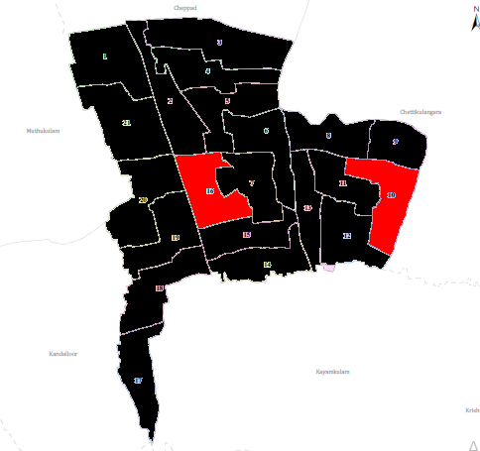

HOT SPOT AREA : WARD -10,16
Ward No | Dengue Total (2021-25) | Leptospirosis Total (2021-25) | Hepatitis A Total (2021-25) | Mumps (2021-25) | ADD (2021-25) | Total Cases
1 | 0 | 0 | 0 | 1 | 18 | 19
2 | 2 | 0 | 0 | 1 | 16 | 19
3 | 1 | 1 | 0 | 1 | 7 | 10
4 | 3 | 1 | 0 | 1 | 17 | 22
5 | 4 | 0 | 0 | 1 | 19 | 24
6 | 1 | 2 | 0 | 1 | 18 | 22
7 | 3 | 1 | 0 | 1 | 12 | 17
8 | 3 | 0 | 0 | 1 | 11 | 15
9 | 7 | 0 | 0 | 1 | 9 | 17
10 | 13 | 0 | 1 | 1 | 18 | 33
11 | 6 | 0 | 0 | 0 | 20 | 26
12 | 5 | 1 | 0 | 0 | 21 | 27
13 | 7 | 0 | 0 | 1 | 8 | 16
14 | 7 | 0 | 1 | 0 | 13 | 21
15 | 5 | 0 | 0 | 0 | 16 | 21
16 | 16 | 0 | 0 | 0 | 18 | 34
17 | 6 | 1 | 0 | 2 | 11 | 21
18 | 4 | 2 | 0 | 2 | 11 | 19
19 | 2 | 0 | 0 | 0 | 10 | 12

By overlaying five years of data, we have identified 'Red Zone' Wards. These are wards where at least two different categories of diseases (e.g., Dengue and Lepto) recurred in consecutive years. Ward 4 is categorized as the Highest Priority Hotspot due to its combination of flood vulnerability and high vector density. Future health infrastructure, such as the proposed R.O plants at should be prioritized.

Preparedness and Response Protocol at LSG Level
This section describes the operational framework for the LSGI once a pandemic is declared. It explains how the LSGI and health system will move from routine data collection to active response, using a One Health approach.

Constitution of One Health Committee
The LSGD shall constitute a One Health Committee comprising the LSGI President, Medical Officers (Modern Medicine, AYUSH, and Veterinary), the Health Inspector, and the Veterinary Surgeon.

Objective: The One Health Committee coordinates human, animal, and environmental health to prevent and control pandemics.

Sl No | Name | Designation | Department/Institution | Role in Committee | Contact Number
1 | K B  PRESANTH | Panchayat President | LSGD | Chairperson | 9349839061
2 | DR SUJALA | Medical Officer (PHC/CHC) | Health Dept | Member Secretary | 9447727430
3 | DR.LEKSHMI | Veterinary Officer | Animal Husbandry | Member | 9447279981
4 | Krishnapriya | Epidemiologist | Health Dept | Member | 8281871060
5 | RAMESH R | Health Inspector/PHN | Health Dept | Surveillance | 9495310360
6 | NAJA | ASHA Supervisor | Health Dept | Community link | 9497633774
7 | SUJATHA | ICDS Supervisor | Social Welfare | Vulnerable groups | 9562891357
8 | NIL | Police Station Officer | Police Dept | Law & order
9 | SREEJITH | Ward Councillor Representative | LSGD | Community coordination | 9745505676
10 | MANIYAMMA | Kudumbashree CDO | Kudumbashree | Community mobilisation | 8111948994
11 | NIL | NGO/Volunteer rep | Civil Society | Support services
12 |  | Line Department representations

Key Responsibilities:
- Review disease surveillance data (human + animal)
- Conduct ward-wise risk assessment and vulnerability mapping
- Approve quarantine/isolation centre locations
- Coordinate with district for resources (PPE, oxygen, ambulances)
- Periodically review health system surge capacity, including beds, oxygen, human resources, and ambulances.
- Approve and monitor risk communication and community engagement strategies, including rumour management.
- Ensure protection and service continuity for vulnerable groups (elderly, persons with disabilities, dialysis patients, coastal populations).
- Conduct quarterly mock drills
- Monitor equity measures for vulnerable groups

Meeting Schedule:
Quarterly (normal times) | Weekly (outbreak alert) | Daily (pandemic phase)

Pandemic Response Workforce
To ensure a coordinated and timely response during a pandemic, a dedicated Pandemic Response Workforce shall be constituted at the LSG level. The workforce will function under the overall supervision of the One Health Committee and in close coordination with the health authorities. Team-based deployment will enable efficient surveillance, case management, quarantine and isolation management, logistics support, and risk communication. Each team shall have a clearly designated team leader, defined roles, and an identified pool of personnel to allow rapid activation, rotation of duties, and continuity of services during prolonged emergencies.

Total Response Workforce Available: 300 persons

Team Name | Composition | Key Responsibilities | Team Leader
Surveillance and Contact Tracing Team | HI, JHI, JPHN, ASHAs and Volunteers | Case detection, contact listing, home visits, reporting | HI
Case Management Team | Doctors, Nurses, MLSP, Palliative Nurses | Patient care & referral | DOCTOR
Quarantine & Isolation Team | LSGD staff, Volunteers | Facility management | JHI
Psychosocial support
Logistics & supply chain Team | LSGD staff, Storekeepers, Drivers 3 | Supplies & transport [PPE, medicines, oxygen, transport, waste management] | Ward Member
Communication Team | Ward members, Kudumbashree, Youth clubs,  AWW workers and other self help groups | IEC, community meetings, countering misinformation | M.O in charge
Transportation | KSRTC, educational institutional buses
Media Surveillance
Intersectoral coordination and convergence
Collaborative surveillance

All teams shall be activated immediately upon outbreak alert or pandemic declaration and shall report daily to the LSG Incident Commander/Medical Officer, with consolidated reporting to the Block PHC. Duty rosters and alternate personnel shall be maintained to ensure uninterrupted services during staff shortages or prolonged response periods. Team composition and numbers may be revised based on the magnitude of the outbreak and availability of human resources.

Activities and Measures before and during Pandemic

PHASE 1 - Alert / Preparation
Surveillance and Reporting-Enhanced syndromic surveillance:
- Data sources for surveillance:
- Event-based triggers (to be monitored and reported):
- Zoonotic and animal health surveillance
- Logistics and Stock Preparedness
  - Identify and empanel local vendors and define emergency procurement mechanisms in accordance with existing LSGD and Health Department norms.
  - Prepare and maintain an essential logistics checklist covering medical supplies, consumables, and support equipment.
  - Pre-identify secure storage locations for emergency stocks and ensure maintenance of stock registers with regular updating.
  - Finalise emergency transport arrangements, including availability of vehicles and identified drivers for rapid deployment during alerts.
  - Designate a Nodal Officer for Logistics to enable prompt decision-making, coordination, and communication during emergencies.
  - Conduct rapid stock verification and ensure availability of minimum buffer stock, including:
- PPE kits – numbers
- Pulse oximeters – ___ numbers
- Hand sanitizers – ___ litres
- Masks, gloves, disinfectants – adequate quantity
Identify critical gaps in logistics and immediately communicate requirements to the Block and District authorities for timely replenishment and support. Monitor expiry dates and stock rotation.

Identification of Quarantine and Isolation Facilities
  - Identify and list suitable buildings for quarantine and isolation (schools, hostels, community halls, etc.).
  - Categorise cases as per the severity and allocate to appropriate facilities (for instance, severe cases to classrooms, mild cases to an assembly hall in case of a school).
  - Facility readiness checklist needed (beds, toilets, ventilation) etc.
  - Find an alternate site if the primary sites are not available or not in use.
  - Identify facility managers and support staff
  - Prepare basic SOPs for:
    - Admission and discharge
    - Food, water, sanitation
    - Infection prevention and waste disposal
  - Ensure availability of basic amenities: water, sanitation, electricity, ventilation, and waste disposal. Prepare a rapid activation plan for these facilities if case numbers increase.

Risk Communication and Community Preparedness
  - Disseminate early warning messages on symptoms, preventive measures, and reporting mechanisms. Display IEC materials both in English and the local language in public places and ensure ward-level awareness.
  - Sensitize elected representatives and community leaders on preparedness measures.
  - Establish a rumour tracking and misinformation response mechanism to identify, verify, and promptly counter false or misleading information.
  - Engage trusted local persons (ward members, ASHA workers, religious leaders, teachers, community volunteers) to communicate official public health messages and reinforce correct practices.
  - Develop and deploy targeted IEC materials for:
    - Schools and educational institutions
    - Markets and commercial areas
    - Work sites and labour settings
  - Conduct community sensitization meetings at the ward level to promote preventive behaviors, address concerns, and strengthen community participation in preparedness and response.

Protection of Vulnerable Groups
Vulnerable populations require priority protection through targeted line-listing, service continuity, and delivery mechanisms.
- Prepare and regularly update line-lists of vulnerable populations, including:
  - Elderly persons living alone
  - Persons with disabilities
  - Pregnant women
  - Migrant workers
  - Dialysis patients
The detailed line-lists shall be maintained as Annexure ___ and updated periodically.

Clinical Dependency Mapping
Develop ward-wise dependency and vulnerability maps to identify households requiring regular support during emergencies. Ensure continuity of essential health services for vulnerable groups, including
- Dialysis services (facility mapping, transport arrangements, and scheduling)
- Continuity of treatment for TB, HIV, and other chronic conditions requiring uninterrupted medication
- Mental health and psychosocial support services
Establish delivery mechanisms for food, essential commodities, and medicines to vulnerable households through coordinated action involving ASHAs, JPHNs, Kudumbashree, volunteers, and local administration.

PHASE 2 - Active Response

Case Identification and Contact Tracing
Case detection and contact tracing activities will be carried out in coordination with the Health authorities, following disease-specific SOPs and IDSP guidelines.
Field Staff Involved
- Health Inspector (HI)
- Junior Health Inspector (JHI)
- Junior Public Health Nurse (JPHN)
- ASHAs and ASHA Supervisors
- Ward-level volunteers and Kudumbashree members (as required)

Screening Checkpoints
Screening checkpoints at high-traffic locations (transport hubs, markets, religious gatherings) for early detection of symptomatic travellers and crowd screening during outbreaks. Potential locations include bus stands, market entry points, and boat jetties, based on local context and risk assessment.
Screening activities will be carried out by trained personnel such as ASHAs, ward members, and volunteers, with support from Health Department staff. Necessary equipment, including non-contact thermometers and appropriate PPE, shall be ensured prior to activation.
Location | Type (Bus stand/Jetty/Market/Railway) | Staff Deployed (ASHAs/Volunteers) | Screening Method | Reporting authority
Bus stand | Transport hub | One JHI  One ASHA  One health Mentors | 1.Swab Collection.  2. Blood smears collection (RDT)  3.Thermal Scanners | Surveillance Nodal Officer in control room
Market entry | Market | One JHI  One ASHA  Male health volunteers | 1.Swab Collection.  2. Blood smears collection (RDT)  3.Thermal Scanners | Surveillance Nodal Officer in control room
Boat jetty | Water transport | One JHI  One ASHA  Male health volunteers | 1.Swab Collection.  2. Blood smears collection (RDT)  3.Thermal Scanners | Surveillance Nodal Officer in control room

Standard Screening Protocol
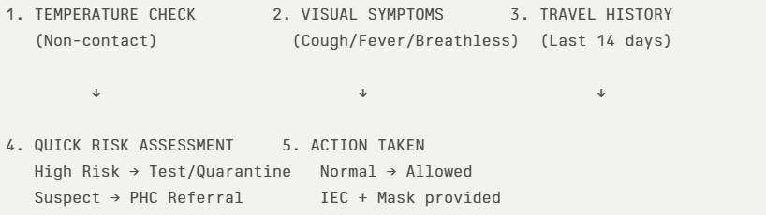
The screening protocol shall include temperature screening, observation for visible symptoms, and inquiry regarding recent travel or exposure history. Individuals identified as suspects during screening shall be immediately referred to the nearest PHC/FHC for further evaluation, testing, and appropriate action as per prevailing guidelines.

Pandemic Control Room
The Pandemic Control Room (PCR) serves as the central nerve center for real-time coordination, data aggregation, decision support, and communication during outbreaks. It consolidates information from all LSGD teams, health facilities and community sources to enable rapid response decisions.

Control Room Infrastructure and Location
Primary Location: ______PATHIYOOR______ Panchayath Office.
Backup Location: Community Hall in _______PATHIYOOR_____ G.P.

Health System Control Room Framework
The PCR is organized into seven functional pillars to ensure no aspect of the response is overlooked:

Rapid Response Team (RRT)
  - Provides immediate intervention during emergencies, clusters, and field alerts.​
  - Coordinates urgent actions such as case investigation, contact tracing, isolation, and inter‑facility referrals.

Data Management & Analytics Team
  - Collects, validates, and manages key health system indicators (cases, tests, beds, HR, supplies).​
  - Analyzes data trends, generates projections, and supports evidence‑based decision‑making for local authorities.

Human Resource Deployment Team
  - Allocates healthcare staff efficiently based on workload and need
  - Ensures adequate and equitable workforce distribution across facilities

Laboratory Surveillance Team
  - Oversees diagnostic testing coordination, sample transport, and timely reporting of results.​
  - Monitors lab indicators (testing volume, positivity rate, turnaround time) for early detection of outbreaks

Vaccination Cell (If Required)
  - Plans and executes vaccination campaigns, including micro‑planning and session scheduling.​
  - Tracks coverage, identifies gaps, and coordinates corrective actions with field teams and outreach services.

Infrastructure & Patient Occupancy Team
  - Monitors facility capacity, earmarked beds, oxygen and critical care resources across all linked facilities.​
  - Ensures optimal patient distribution and referral management using updated bed‑status and resource data.
  - BMWM

Communication team
- Logistics and supply chain
- Transportation (interfacility & emergency transport)
- Media surveillance Call centre
- Management of the deceased
- Intersectoral coordination and convergence

Key Control Room Team
The Control Room Team coordinates all pandemic response activities within the LSGD and serves as the single command and communication hub during activation. It integrates information, field actions, logistics, and policy execution across all participating departments and health facilities.

Role | Name | Designation | Contact Number | Responsibility
In-charge/Nodal Officer | DR SUJALA | MEDICAL OFFICER | 9447727430 | Overall coordination, decision-making, and reporting to the District level.
Data Entry Operator | NIL | 0 | 0 | Managing the line list, updating dashboards, and tracking testing results.
Communication Officer | NIL | 0 | 0 | Handling the public helpline, coordinating ambulance dispatch, and contact tracing calls.
Logistics Coordinator | NIL | 0 | 0
Technical Support (IT/Data) | NIL | 0 | 0

SOP for alert escalation/trigger point with mapping of responsibilities.
Key Points:
- The Control Room shall be staffed with a designated In-charge, data entry personnel, and communication staff with clearly defined roles and shift arrangements.
- It shall maintain updated records on daily monitoring indicators including new cases, persons under active quarantine, and hospital bed occupancy.
- All reports and situation updates shall be shared daily with the Block and District Surveillance Unit.
- The Control Room shall act as a single point of contact for coordination with response teams, health institutions, and other departments.
- Contact details of the Control Room shall be widely communicated to field staff and stakeholders during activation.

Daily Monitoring Indicators
To ensure timely decision-making and effective response, the following key indicators shall be monitored and updated on a daily basis by the Pandemic Control Room:

Epidemiological Indicators:
New cases reported today, Total active cases, Test Positivity Rate (TPR), Case Fatality Rate (CFR)
- Surveillance Indicators:
Persons under home quarantine, High-risk contacts identified, Fever, ILI, SARI or other symptoms (syndromic surges), Travellers (symptomatic or high-risk arrivals),Animal husbandry surveillance (zoonotic alerts, unusual animal deaths, poultry/bird flu signals), Mortality surveillance (excess deaths, unexplained fatalities, verbal autopsy reports)
- Logistics and Infrastructure Indicators:
Hospital / CFLTC beds occupied, Oxygen cylinders/concentrators available, Ambulances on standby
- Alert Findings
The following table outlines category-specific trigger points (red flags) from surveillance indicators and corresponding immediate actions for the Pandemic Control Room. These enable rapid response to alert findings like testing anomalies, positive cases exceeding thresholds, clusters, and WGS reports.

Category | Trigger Pophint (Red Flag) | Immediate Action
Clusters | Geographical or facility-based: 5+ cases linked to one location (office, school, street). | Declare a micro-containment zone; perimeter control and active case finding.
Testing | Sudden drop in testing volume / delay in reporting / unusual testing trends | Review the sample collection process, address lab bottlenecks, deploy additional testing teams, and notify the District Lab.
Lab | Test Positivity rate increases | Increase testing sites in that ward.
Hospital | >80% Oxygen bed occupancy | Activate backup/CFLTC beds.
Travel | Cluster of cases from a single flight/train or high-risk arrival group. | Trace all passengers in adjacent seats; implement mandatory institutional quarantine.
Animal | Mass poultry/wildlife death or unusual sickness | Notify Animal Husbandry, sample the area, and dispatch RRT for environmental sampling and zoonotic check.
Mortality | Sudden spike in home deaths or brought-in-dead (BID) cases | Audit the deaths and Active Case Search drive
Additional investigations like Whole Genome Sequencing (WGS) | Detection of a Variant of Concern (VOC) or Variant of Interest (VOI) | Implement strict micro-containment; update clinical protocols to match variant severity.

Communication of Public Health Information
A Community Communication Hub shall be established to ensure timely, accurate, and consistent dissemination of information during a pandemic. The Hub will function under the coordination of Nodal officers of the control room and act as the nodal point for public communication, risk messaging, and community engagement. It will support dissemination of official advisories, promote preventive behaviors, address rumors and misinformation, and ensure that messages reach all sections of the population through trusted local channels and leaders.

Key communicators
Channel | Responsible Person | Contact
Ward-level announcements | NIL
Social media | NIL
Local Cable TV/Radio | NIL

- All messages disseminated through the Hub shall align with advisories issued by the Health Department and District authorities.
- Community leaders shall be sensitized to support behavior change, reduce stigma, and counter misinformation.
- Special efforts shall be made to reach vulnerable and hard-to-reach populations using locally appropriate communication methods.

Rumor Tracking: A designated volunteer will monitor local social media/WhatsApp groups daily to identify misinformation and issue official clarifications via the Communication Hub.

Coordination with District/State Authorities & Other Organisations
Effective coordination with Block, District, and State authorities is essential to ensure timely reporting, technical guidance, and uninterrupted supply of essential resources during a pandemic. The LSG shall establish clear communication channels, designate responsible officers, and adhere to prescribed reporting timelines to support coordinated public health action and efficient resource mobilisation.

Key Details:
- Nodal Officer for Reporting:
- Contact Number:
Reporting Schedule and Protocols:

To Whom | What to Report | Frequency | Nodal Person
Block PHC | Complete Situation Report (Cases, Quarantine, Beds, Screening, Deaths) | NIL
District IDSP Unit | Outbreaks/Clusters/Unusual Events (>5 cases same ward) | NIL
Veterinary Officer | Animal health events/Zoonotic alerts
State Cell | Zoonotic cross-sector events

Supply Chain Coordination
The LSG shall coordinate closely with Block, District, and State authorities (KMSCL) to ensure uninterrupted availability of essential goods, medical supplies, and logistics during a pandemic. Supply requirements shall be assessed regularly based on case load and communicated promptly to the appropriate authorities for timely replenishment.
Key Points:
- Maintain updated contact details of District and Block nodal officers for health logistics, oxygen supply, ambulances, and essential medicines.
- Submit timely indent requests for PPE, testing kits, medicines, oxygen, and other critical supplies through prescribed channels.
- Monitor stock levels at LSGD facilities, quarantine/isolation centres, and field teams through daily stock registers and dispensing logs to prevent shortages.
- Coordinate with District authorities, Karunya/Neethi medical shops, and local purchase committees for funds allocation and emergency procurement.

- Ensure regular monitoring of dispensing registers at all facilities to track usage, expiry, and pilferage—shortages being a perennial issue requiring proactive weekly audits.

- Activate surge procurement protocols during high caseloads, leveraging local purchase powers under LSGD funds alongside state supplies.

Resource Inventory and Contacts
Resource Category | Source  (District/State/Private) | Contact
PPE Kits/Masks/Gloves | KMSCL
PPE Kits/Masks/Gloves | Local Vendors
Oxygen  Cylinders/Concentrators | KMSCL
Medicines/Antivirals | KMSCL
Medicines/Antivirals | Neethi Shops
Test Kits (RTPCR/Rapid) | KMSCL

Collaboration with NGOs, PPP, and CSR
To augment government efforts during a pandemic, the LSG shall collaborate with NGOs, voluntary organisations, and private sector partners through public–private partnerships and Corporate Social Responsibility (CSR) initiatives, in coordination with District authorities.

Key Points:
- Engage NGOs and community-based organisations for community outreach, awareness, and support to vulnerable populations.
- Leverage CSR support for procurement of medical equipment, PPE, oxygen concentrators, food kits, and sanitation materials, as permitted.
- Ensure all collaborations align with government guidelines and are routed through approved administrative and financial procedures.
- Maintain transparency and documentation for all external support received and utilised.
Organization | Type | Support Offered | Contact Person
Youth Clubs/Student Unions | CBO

Interdepartmental Coordination
Coordination among departments during a pandemic shall be ensured through regular review meetings convened by the LSGD President. These meetings will provide a structured platform for sharing situational updates, assessing resource availability, resolving operational gaps, and taking joint decisions to ensure a coordinated and timely response.

Department | Representative | Key Role | Contact
Health (PHC) | Staff Nurse : | Case management | 9544391279
Veterinary | Veterinary Surgeon: | Animal surveillance
ICDS | Supervisor: Sindhu | Nutrition support
Education | Head Teacher: | School coordination
Police |  | Containment enforcement | __________
Water Authority | __________ | Water supply | __________
LSGD Engineering | __________ | Quarantine infrastructure | __________

PHASE 3 - Surge Capacity
Phase 3 is activated when there is a rapid increase in cases, high test positivity rates, or when existing health facilities and quarantine arrangements approach saturation. The focus of this phase is to expand isolation capacity, augment clinical care services, and mobilise additional resources through district and state support mechanisms.

Conversion of Community Facilities
To manage increased case load, the LSGD shall activate additional isolation facilities by repurposing identified community infrastructure such as community halls, auditoriums, schools, hostels, or other suitable buildings.

Name of facility | Facility Type | No. of Buildings | Ward | Surge Capacity (Beds) | Nodal Person
ELEMECS HOSPITAL | HOSPITAL | 3 | 5 | 265

- Recovery and rehabilitation phase
- Recovery
  - Damage & impact assessment
  - Restoration of health services
  - Rehabilitation of affected population
  - Psychosocial & mental health support
  - Disease surveillance during recovery phase
  - Environmental cleanup & sanitation
  - Livelihood restoration
  - Community engagement & confidence building
  - Documentation & after-action review
  - Lessons learned & best practices
  - Health system strengthening
  - Policy revision & preparedness enhancement
  - Research

CONCLUSION

Additional points
- tech support
- relief based commodities
- ham reading operators
- hazard vulnerability mapping
- Kseb & other power source
- HR specific responsibility

RECOMMENDATIONS

Strengthening Healthcare Infrastructure
- Establish a primary health response unit within the Panchayat with trained staff.
- Ensure availability of basic medical supplies (masks, sanitizers, PPE kits, oxygen cylinders).
- Create tie-ups with nearby hospitals in ____________ for emergency referral and transport.

2. Community Awareness & Education
- Conduct regular awareness campaigns on hygiene, vaccination, and preventive measures.
- Use local communication channels (community radio, WhatsApp groups, notice boards) to spread verified information.
- Train volunteers to act as health ambassadors in each ward.

3. Emergency Response & Coordination
- Form a Pandemic Preparedness Committee at Panchayat level including health workers, ward members, and NGOs.
- Develop a clear action plan for lockdowns, quarantine, and distribution of essentials.
- Maintain a database of vulnerable groups (elderly, differently-abled, chronically ill) for targeted support.

4. Supply Chain & Food Security
- Identify and support local suppliers and farmers to ensure uninterrupted food supply.
- Create community kitchens during emergencies to serve vulnerable populations.
- Stockpile essential commodities in Panchayat-run outlets for crisis periods.

5. Digital Preparedness
- Promote digital platforms for telemedicine consultations.
- Use Panchayat’s website/social media for real-time updates on health advisories.
- Encourage online grievance redressal to reduce crowding in offices.

6. Training & Capacity Building
- Organize mock drills for pandemic response in schools, offices, and public spaces.
- Train Panchayat staff and volunteers in first aid, infection control, and crowd management.
- Collaborate with NGOs and health departments for capacity-building workshops.

7. Long-Term Resilience
- Integrate pandemic preparedness into the Panchayat Development Plan.
- Allocate a dedicated budget for health emergencies.
- Encourage community participation in planning and monitoring preparedness measures.

MOCKDRILL SCENARIOS

FIRST AID WORKSHOP CONDUCTED
FIRE AND SAFETY WORKSHOP CONDUCTED

ANNEXURE

IMPORTANT PHONE NUMBERS

Phone numbers and particulars of persons responsible for providing guidance, assistance, and support for pandemic preparedness operations may be provided here in a manner that allows easy reference at a glance. The information recorded here could be exhibited elsewhere at the time of emergencies. LSG institutions shall give special attention to collect and record the above data of persons and institutions who/which are supposed to give technical and co-ordination support to reduce the impact of pandemic.

1.1. Details of grama panchayat/municipality/corporation wards
Sl.No | Name of the ward | Ward number | Name of the ward  member | Contact number
1 | RAMAPURAM | 1 | SOUMYA | 8606232101
2 | EVOOR | 2 | JAYA SATHEESH | 8086463562
3 | EVOOR SOUTH | 3 | SAKUNTHALA | 9961713046
4 | EVOOR SOUTH | 4 | DEEPA | 9249317168
5 | PATHIYOORKALA | 5 | USHA | 9747931574
6 | PATHIYOOR TEMPLE | 6 | HARI | 9495240002
7 | PATHIYOOR | 7 | ADV SREEJITH | 9745505676
8 | PATHIYOOR EAST | 8 | HARIKUMAR | 8547198410
9 | BHAGAVATHIPPADI | 9 | R RAJESH | 9048157795
10 | ERUVA | 10 | RAKHI | 7994768863
11 | KUTIKULANGARA | 11 | VIJITHA VIJAYAN | 8590646521
12 | ERUVA | 12 | K SUKUMARAN | 9495872918
13 | SREEJITH PR | 13 | SREEJITH | 8891189179
14 | ERUVA WEST | 14 | AISWARYA GOPINATHAN | 7356177102
15 | ERUVA | 15 | DEEPAK | 9895434497
16 | PATHIYOOR WE ST | 16 | B S PREMOD | 7306868898
17 | KEERIKKAD | 17 | SANGEETHA SUJIT | 9495447796
18 | KAREELAKULANGARA | 18 | S RAJENDRAN | 9447104574
19 | PUTHEN ROAD | 19 | K B PRESANTH | 9349539061
20 | KAREELAKULANGARA | 20 | C R SUKEKHA | 9747094593
21 | PULLUKULANGARA | 21 | SASIKALA | 7025464110

1.2. Other important phone numbers of grama panchayat/municipality/corporation area
Sl. No. | Name | Contact number
1. | PANCHAYATH SECRETORY–SINDHU | 9526077216
2. | PRESIDENT—K B PRESANTH | 9349839061
3.
4.
5.
6.
7. | Excise department
8. | Forest department

1.3. Important offices of grama panchayat/municipality/ corporation
Sl.No | Name of the office | Contact person | Contact number
1. | Village Office | Village Officer | 8606819364
2. | Agriculture Office | Agriculture Officer | 9383470648
3. | Animal Husbandry Office | Animal Husbandry Doctor | 9444279981
4. | Police Station | Police Officer | 9497980276
5. | BSNL Office | Officer | 0477 2252000
6. | Block Office | Officer
7. | KSEB Office | Officer | 9496001912
8. | Fisheries Office | Officer | NIL
9. | Fire and Rescue | Officer | 04792442101

1.4. Health Services

Sl. No | Name of the hospital/institution | Location | Phone number
1. | Government hospitals/PHC | PATHIYOOR | 9447727430
2. | Private hospitals | KAREELAKULANGARA | 9809191616
3. | Clinical laboratories
4. | Chemist/pharmacy
5. | Blood donors
6. | Other language experts (Bihari, Hindi, Bengali,  Asamees ………)

1.5. Veterinary Services
Sl.No | Name of the Clinic | Name of the  Surgeon/Doctor | Place/location | Phone  number
1 | Govt.Veterinary Hospital | DR.LEKSHMI | PATHIYOOR | 9447279981

1.6. Helpline numbers
Helpline | Phone number
Police | 04792445929
Fire and Rescue | 04792442101
KSEB | 04792476796

1.7. Public and Private Schools Contact details

S.No | Name of School | Institution type | Phone number
1 | MMKM LPS | AIDED | 7012846960
2 | SRKV LPS,THOONETH | GOVT | 9745393752
3 | SRKV GLPS EVOOR | GOVT | 9446823137
4 | SKV LPS PULIYARA | AIDED | 9496112286
5 | GLPS KEERIKKAD | GOVT | 9497811650
6 | MGM LPS | AIDED | 9947575321
7 | ARATUKULANGARA LPS | AIDED | 7025143169
8 | AISWARYA PREDHAYINI UPS | AIDED | 9745988361
9 | RAMAPURAM H S | GOVT | 9400752928
10 | NRPM HS,PULLUKULANGARA | AIDED | 9447266882
11 | SKV HS PULIYARA | AIDED | 9495162960
12 | PATHIYOOR H S | GOVT | 9747099471
13 | RAMAPURAM HSS | GOVT | 9496274765
14 | NRPM H S S PULLUKULANGARA | AIDED | 9447565246
15 | SN CENTRAL SCHOOL | PRIVATE
16 | KIT ENGLISH MEDIUM SCHOOL | PRIVATE | 9605920107

1.9. Anganwadi Contact Details

Ward No | Name of Anganwadi Teachers | Phone number
6 | Vasanthakumari | 8590530749
17 | kamalamma | 9995054572
18 | Reshma | 7994257084
14 | syamala | 9605897556
14 | Sreekala | 8921495428
4 | Sushamma | 9846560302
6 | REMA | 9744261843
6 | OMANA | 9947302837
16 | SUJA | 9567542976
16 | LEELAMANI | 9745744094

Ward No | Anganwadi No and Name of Teacher | Phone number
15 | ANJALI | 9495462814
 | NESIYATH | 9526997371
13 | ANNI AMMA | 8229543879
19 | GIRIJA | 8606898588
 | USHA | 7025470994
 | USHA | 8606651378
13 | REMA | 9744084380
2 | SHEEJA | 9995029912
7 | NISHA | 7025143169
9 | GIRIJA | 9656322626
12 | NISHA | 9400394450
10 | PRIYA | 9061217981
11 | SREEKUMARI | 9633385993
11 | SANTHI | 9061514791
8 | GEETHA | 9207624435
1 | SYAMILI | 9605256476

1.12. Information regarding resources

Means of transportation | Name of Owner | Phone Number
Heavy Trucks
Tractor
Ambulances
Boats
Taxi service

Annexure 1: LSG Baseline Data Collection Format
A. Baseline data
Sl. No. | Indicator / Field | Baseline Data | Source / Remarks
1 | Name of LSG | PATHITOOR
2 | District | ALAPPUZHA
3 | Block / Taluk | MUTHUKULAM
4 | Type of LSG (Gram Panchayat / Municipality / Corporation) | GRAMMA PANCHAYATH
5 | Area (sq. km) | 40.12
6 | No. of wards | 21
7 | GIS boundary file available | (Yes/No
8 | Key contact person & phone

B. Demography
Indicator / Field | Baseline Data | Source / Remarks
Total population | 39744 | LSGD
Males | 19360 | FHC
Females | 20384 | FHC
Transgender population | 0
Age distribution  (<5, 5–14, 15–59, ≥60) | 1375,3681,27115,,7573 | FHC
No. of households | 3944 | FHC
Population density (persons/sq.km) | 993.6 | FHC
No. of migrant workers | 398 | FHC
Major occupational groups

C. Vulnerable Populations & Social Risks
Sl. No. | Indicator / Field | Baseline Data (Value / Description) | Source / Remarks
1 | No. of elderly (≥60) | 7573 | FHC
2 | No. of persons with disability | 123 | FHC
3 | No. of bedridden persons | 84 | FHC
4 | No. of chronic disease cases (DM/HTN/COPD/CKD etc.) | 7254 | FHC
5 | Pregnant women (current estimate) | 169 | FHC
6 | Children <5 years | 1375 | FHC
7 | Tribal population (if any) | 57 | FHC
8 | Fisherfolk / coastal vulnerable groups (if any) | 23 | FHC
9 | Urban slums / unnotified settlements (if any) | NIL
10 | Homeless population | 262 | LSGD
11 | Orphanages / old age homes (number & capacity) | NIL
12 | Hostels / prisons / shelters (number & capacity) | NIL
13 | Poverty / BPL estimate | 4123
14 | Food insecurity hotspots | NIL
15 | Any history of stigma/discrimination issues (Yes/No) | NIL

D. Health System & Service Readiness
Sl. No. | Indicator / Field | Baseline Data (Value / Description) | Source / Remarks
1 | No. of health facilities in LSG (PHC/CHC/TH/DH/Private) | 18
2 | PHC/Family Health Centre details (name, location) | PHC PATHIYOOR
3 | Subcentres / Health & Wellness Centres (number) | 7
4 | Private clinics / hospitals (number) | 7
5 | Labs available (public/private) | 8
6 | Availability of ambulance services (Yes/No, number) | NO
7 | Availability of isolation/quarantine facilities (Yes/No, details) | NO
8 | Cold chain facilities (Yes/No, details) | NO
9 | Stockpile space available (Yes/No) | NO
10 | PPE / mask / sanitizer availability plan (Yes/No) | NO
11 | Surveillance staff available (JHI/JPHN/ASHA count) | YES
12 | Existing emergency referral pathways (Yes/No) | NO

E. Points of Entry & Mobility
Sl. No. | Indicator / Field | Baseline Data (Value / Description) | Source / Remarks
1 | Bus stands / depots (number) | NO
2 | Railway stations (number) | NIL
3 | Boat jetties / fishing harbours (number) | NIL
4 | Ports / airports nearby (specify distance) | NIL
5 | Major highways/roads passing through | NH 66
6 | Border crossings (state/district) | NIL
7 | Major markets / weekly markets | NIL
8 | Tourism hubs / major event venues | NIL
9 | Schools/colleges with hostels (number) | NIL
10 | Factories / large workplaces (number) | 1— SPINNING MILL
F. Water, Sanitation & Hygiene (WASH)
Sl. No. | Indicator / Field | Baseline Data (Value / Description) | Source / Remarks
1 | Major drinking water sources (piped / wells / borewells / springs) | 7658 | LSGD
2 | No. of public wells | 21 | LSGD
3 | No. of households with piped water connection | 78
4 | Water quality testing routine (Yes/No) | NO
5 | Common contamination risks (flooding, salinity, industrial waste) | NIL
6 | Open defecation free status (Yes/No) | NIL
7 | Solid waste management system (Yes/No) | YES | FHC
8 | Bio-medical waste disposal mechanism (Yes/No) | YES | FHC
9 | No. of public toilets | NIL
10 | Handwashing stations in public places (Yes/No) | NIL
G. Zoonotic Risks & One Health
Sl. No. | Indicator / Field | Baseline Data (Value / Description) | Source / Remarks
1 | Livestock population (cattle/goats/pigs/poultry) – estimates | 3402 | VETERINARY
2 | No. of dairy farms / poultry farms / pig farms | 2-DIARY FARMS
3 | Slaughterhouses / meat shops (number) | 4–PULLUKULANGARA | VETERINARY
4 | Animal markets (Yes/No, details) | NIL
5 | Veterinary dispensaries (number) | 1
6 | History of zoonotic outbreaks (rabies, leptospirosis, avian flu etc.) | NIL
7 | Stray dog population management measures (Yes/No) | NO
8 | Rodent infestation hotspots (Yes/No) | NO
9 | Wetlands / waterlogged areas prone to leptospirosis | NIL
10 | Bat roosting areas / caves / fruit orchards (if any) | NIL
11 | Human-animal interface hotspots (farms near residences) | NI
H. Climate & Disaster Risks (Pandemic Amplifiers)
Sl. No. | Indicator / Field | Baseline Data (Value / Description) | Source / Remarks
1 | Flood-prone wards (list) | 6,7,8,12 | LSGD
2 | Landslide-prone wards (list) | NIL
3 | Cyclone/sea surge risk (Yes/No) | NIL
4 | Heatwave risk zones (Yes/No) | NIL
5 | Waterlogging areas (list) | NIL
6 | Shelter homes / relief camps (number, capacity) | NIL
7 | Past disaster displacement history | FLOOD RELATED CAMP
8 | Disruption to water supply/transport common (Yes/No) | NO
I. Critical Infrastructure & Logistics
Sl. No. | Indicator / Field | Baseline Data (Value / Description) | Source / Remarks
1 | Schools (number) | 16 | FHC
2 | Anganwadis (number) | 32 | FHC
3 | Colleges (number) | 2 | FHC
4 | Community halls (number) | 2 | LSGD
5 | Places of worship with large gatherings (number) | 0 | LSGD
6 | Large markets / shopping areas (number) | NIL
7 | Warehouses / cold storages (number) | NIL
8 | Telecom/mobile network coverage gaps (Yes/No) | NO
9 | Power outage frequency (high/medium/low) | NIL
10 | Availability of generators in key facilities | NIL

J. Risk Communication & Community Networks
Sl. No. | Indicator / Field | Baseline Data (Value / Description) | Source / Remarks
1 | Ward-level rapid response teams (Yes/No) | YES | LSGD
2 | Jagratha samithis / committees active (Yes/No) | YES | LSGD&PHC
3 | Kudumbashree presence and strength (number of units) | YES, 360 | LSGD
4 | Volunteer network (number, coverage) | 931 | LSGD&PHC
5 | Community-based surveillance mechanisms (Yes/No) | YES | PHC
6 | IEC dissemination channels (WhatsApp groups, community radio, PA systems) | YES | FHC&LSGD
7 | Rumour tracking mechanisms (Yes/No) | YES | LSGD
8 | Languages spoken / literacy considerations | YES | LSGD
9 | Vulnerable groups communication strategy available (Yes/No) | YES | LSGD

K. Preparedness Planning & Governance
Sl. No. | Indicator / Field | Baseline Data (Value / Description) | Source / Remarks
1 | LSG emergency plan available (Yes/No) | YES | LSGD
2 | Pandemic preparedness plan available (Yes/No) | YES | LSGD
3 | Incident Command System identified (Yes/No) | YES | FHC
4 | Rapid procurement mechanism available (Yes/No) | YES | FHC ,LSGD
5 | Emergency fund available (Yes/No, amount) | YES | LSGD
6 | Past outbreak response experience (Yes/No, details) | YES | FHC
7 | Intersectoral coordination mechanism (Health, Police, LSG, Veterinary, Education) | YES | FHC
8 | Mock drills conducted in last 12 months (Yes/No) | NIL
9 | Training coverage for staff/volunteers (Yes/No) | YES

L. Surveillance & Data Systems
Sl. No. | Indicator / Field | Baseline Data (Value / Description) | Source / Remarks
1 | Digital reporting tools used (e.g., DHIS2, portals) | HMIS,UWIN PORTAL | DHS
2 | Availability of line-listing format (Yes/No) | YES | DHS
3 | Contact tracing team identified (Yes/No) | YES | FHC
4 | Mapping of high-risk households available (Yes/No) | YS | LSGD
5 | Testing sample transport mechanism (Yes/No) | YES | HUB&SPOKE
6 | Reporting timeline adherence (good/average/poor) | GOOD | FHC
7 | Data sharing between departments (Yes/No) | YES | ONE HEALTH
8 | Availability of dashboard for monitoring (Yes/No) | YES | DHS

M. Additional Notes & Observations
Sl. No. | Indicator / Field | Baseline Data (Value / Description) | Source / Remarks
1 | Key challenges perceived by LSG | FLOOD | LSGD
2 | Top 5 high-risk wards (reason) | 6,12,7,8,16—--FLOOD | LSGD
3 | Any unique local risks (industrial pollution, refugee camps, etc.) | NIL | NIL
4 | Recommendations for preparedness strengthening | NIL | NIL

